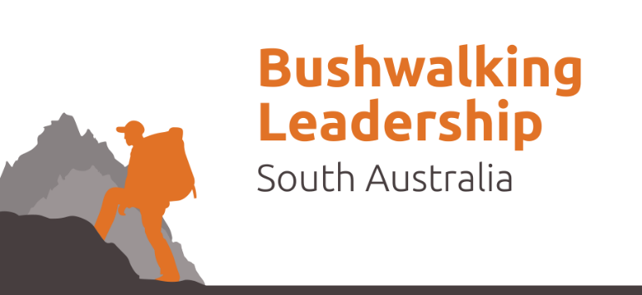

Medical information & Acknowledgement of Risk Form

Assistant Bushwalking Leadership Course

PARTICIPANT DETAILS

Participant’s Name: | Date of Birth:
Address:
Phone Numbers: (H) (M) (W)

EMERGENCY CONTACT DETAILS (While on trip)

#1 Contact Name: | Relationship:
Phone Numbers: (H) (M) (W)
#2 Contact Name: | Relationship:
Phone Numbers: (H) (M) (W)

Continued over page …

PARTICIPANT MEDICAL INFORMATION

1. Are you covered by private health insurance? | YES / NO
Name of Fund: and policy number
2. Are you covered by Ambulance subscription? | YES / NO
3. Medicare Number:
4. Do you have / have you had asthma? | YES / NO
Trigger factors:
Severity:
Treatment / Medication:
5. Do you have / have you had any allergies? | YES / NO
Trigger factors:
Severity:
Treatment / Medication:
6. Do you require medication for any other conditions? | YES / NO
Name of medication:
Reason for medication:
When is it taken:
7. Have you had any recent illness / surgery? | YES / NO
Details:
8. Do you have any other medical conditions that may affect your  participation | YES / NO
Details:
9. Fitness Ability POOR / FAIR / GOOD / EXCELLENT
10. Do you have any special dietary requirements? | YES / NO
Details:

Continued over page …

I ___________________________ understand the nature of the activity and the risks in the activity. These include and are not exclusive to drowning, broken limbs, twisted & damaged joints through falling or being fallen on, animal bites including snakes, injury through exposure to weather, burns & cuts through stove use & other possibilities.

I understand anything I do on this event is my own responsibility. I understand I will not be forced to do anything I do not wish to do. I understand the nature of this training is to develop my skills beyond their current levels.

I understand that this activity may be cancelled or experience delays for weather & safety reasons.

I understand that I may be refused onto training programs (without refund) if not properly equipped or prepared.

In case of an emergency I allow Bushwalking Leadership SA event/trip leader to take me for medical assistance by car, ambulance, or other emergency services vehicles at my expense. I allow First Aid to be administered by current Senior First Aid qualified Bushwalking Leadership SA designated people.

I have discussed the activity with Bushwalking Leadership SA and have clarified any areas of concern prior to signing this consent form. I have filled out this medical form honestly, and to the best of my knowledge.

Signature: ___________________________________ Date: ___ / ___ / ____

